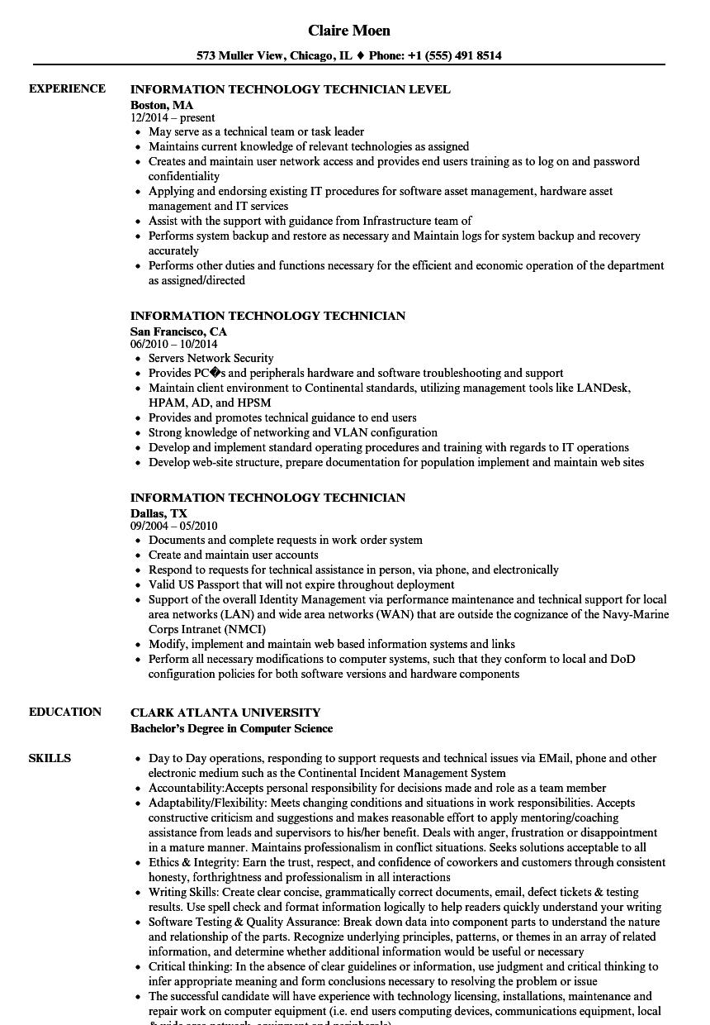
EXPERIENCE
EDUCATION
SKILLS
Claire Moen
573 Muller View, Chicago, IL ♦ Phone: +1 (555) 491 8514
INFORMATION TECHNOLOGY TECHNICIAN LEVEL
Boston, MA 12/2014-present
May serve as a technical team or task leader
• Maintains current knowledge of relevant technologies as assigned
• Creates and maintain user network access and provides end users training as to log on and password confidentiality
• Applying and endorsing existing IT procedures for software asset management, hardware asset management and IT services
• Assist with the support with guidance from Infrastructure team of
• Performs system backup and restore as necessary and Maintain logs for system backup and recovery accurately
• Performs other duties and functions necessary for the efficient and economic operation of the department as assigned/directed
INFORMATION TECHNOLOGY TECHNICIAN
San Francisco, CA
06/2010 - 10/2014
⚫ Servers Network Security
• Provides PCs and peripherals hardware and software troubleshooting and support
• Maintain client environment to Continental standards, utilizing management tools like LANDesk, HPAM, AD, and HPSM
• Provides and promotes technical guidance to end users
• Strong knowledge of networking and VLAN configuration
• Develop and implement standard operating procedures and training with regards to IT operations
• Develop web-site structure, prepare documentation for population implement and maintain web sites
INFORMATION TECHNOLOGY TECHNICIAN
Dallas, TX
09/2004-05/2010
• Documents and complete requests in work order system
• Create and maintain user accounts
• Respond to requests for technical assistance in person, via phone, and electronically
• Valid US Passport that will not expire throughout deployment
• Support of the overall Identity Management via performance maintenance and technical support for local area networks (LAN) and wide area networks (WAN) that are outside the cognizance of the Navy-Marine Corps Intranet (NMCI)
• Modify, implement and maintain web based information systems and links
• Perform all necessary modifications to computer systems, such that they conform to local and DoD configuration policies for both software versions and hardware components
CLARK ATLANTA UNIVERSITY
Bachelor's Degree in Computer Science
⚫ Day to Day operations, responding to support requests and technical issues via EMail, phone and other electronic medium such as the Continental Incident Management System
• Accountability: Accepts personal responsibility for decisions made and role as a team member
• Adaptability/Flexibility: Meets changing conditions and situations in work responsibilities. Accepts constructive criticism and suggestions and makes reasonable effort to apply mentoring/coaching assistance from leads and supervisors to his/her benefit. Deals with anger, frustration or disappointment in a mature manner. Maintains professionalism in conflict situations. Seeks solutions acceptable to all • Ethics & Integrity: Earn the trust, respect, and confidence of coworkers and customers through consistent honesty, forthrightness and professionalism in all interactions
⚫ Writing Skills: Create clear concise, grammatically correct documents, email, defect tickets & testing results. Use spell check and format information logically to help readers quickly understand your writing • Software Testing & Quality Assurance: Break down data into component parts to understand the nature and relationship of the parts. Recognize underlying principles, patterns, or themes in an array of related information, and determine whether additional information would be useful or necessary
⚫ Critical thinking: In the absence of clear guidelines or information, use judgment and critical thinking to infer appropriate meaning and form conclusions necessary to resolving the problem or issue
• The successful candidate will have experience with technology licensing, installations, maintenance and repair work on computer equipment (i.e. end users computing devices, communications equipment, local

